RIGA TECHNICAL UNIVERSITY

FACULTY OF COMPUTER SCIENCE AND INFORMATION TECHNOLOGY

INSTITUTE OF APPLIED COMPUTER SYSTEMS

Homework #3

“Large Databases”

**Use of object methods for data extraction from ORDB data storage structures. Java language use in database server.**

Author: Oleg Tsoy

Course, group: ADBD0

Student card no.: 131ADB042

2014 / 2015 study year

**Content**

1 Goal 3

2 Task 3

3 Database description 4

4 SQL queries 5

5 Conclusions 25

6 References 26

# Goal

Learn more about usage of object methods for data extraction from ORDB data storage structures. How we can use Java programming language in the database server.

# Task

1. Creation and test of **MAP** type method.

2. Creation and test of **ORDER** type method.

3. Creation and test of **MEMBER** type method.

4. Creation and test of user-defined constructor method.

5. Java class creation and loading in database:

1) using LOADJAVA program;

2) using CREATE JAVA command.

Java class meta-date inspection (SELECT).

Creation of PL/SQL function which call Java method. Execution of Java method.

6. Java class creation, loading and testing for SELECT query realization.

7. Conclusions (what seems good, what bad, what like, what is problematic).

# SQL queries

***1. Query goal (MAP type method):***

***Query SQL code***

*CREATE TYPE STUDENT_TYPE2*

*AS*

*OBJECT*

*(*

*STUDENT_ID NUMBER,*

*MATHEMATICS_MARK NUMBER,*

*LDATABASE_MARK NUMBER,*

*LANGUAGE_MARK NUMBER,*

*MAP MEMBER FUNCTION AVERAGE_MARK*

*RETURN NUMBER);*

***Result of execution***

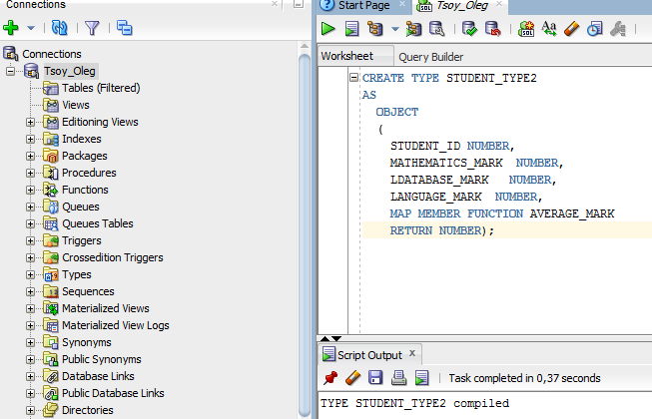

***Analysis of results, what in these data can be seen:*** *As can be seen from the screenshot I have created the STUDENT_TYPE2 as an object for my project.*

***2. Query goal (MAP type method):***

***Query SQL code***

*CREATE OR REPLACE TYPE BODY STUDENT_TYPE2*

*AS*

*MAP MEMBER FUNCTION AVERAGE_MARK*

*RETURN NUMBER*

*IS*

*BEGIN*

*RETURN (SELF.MATHEMATICS_MARK+SELF.LDATABASE_MARK+SELF.LANGUAGE_MARK)/3;*

*END AVERAGE_MARK;*

*END;*

***Result of execution***

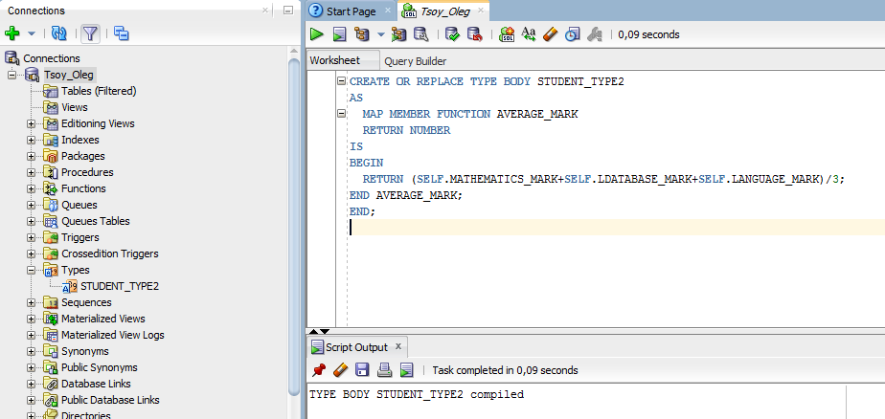

***Analysis of results, what in these data can be seen:*** *In this case I have compiled STUDENT_TYPE2 with MAP MEMBER FUNCTION.*

***3. Query goal (MAP type method):***

***Query SQL code***

*CREATE TABLE STUDENTS_WITH_MARKS OF STUDENT_TYPE2;*

*INSERT INTO STUDENTS_WITH_MARKS VALUES*

*( STUDENT_TYPE2(10,8,9,9)*

*);*

*INSERT INTO STUDENTS_WITH_MARKS VALUES*

*( STUDENT_TYPE2(4,6,10,9)*

*);*

***Result of execution***

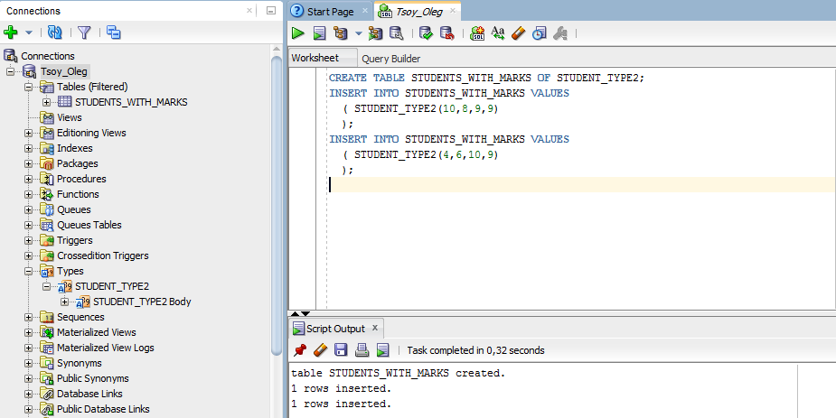

***Analysis of results, what in these data can be seen:*** *I have created STUDENT_WITH_MARKS table and 2 rows of data were inserted into this table.*

***4. Query goal (MAP type method):***

***Query SQL code***

*SELECT VALUE(A).AVERAGE_MARK() from STUDENTS_WITH_MARKS A;*

***Result of execution***

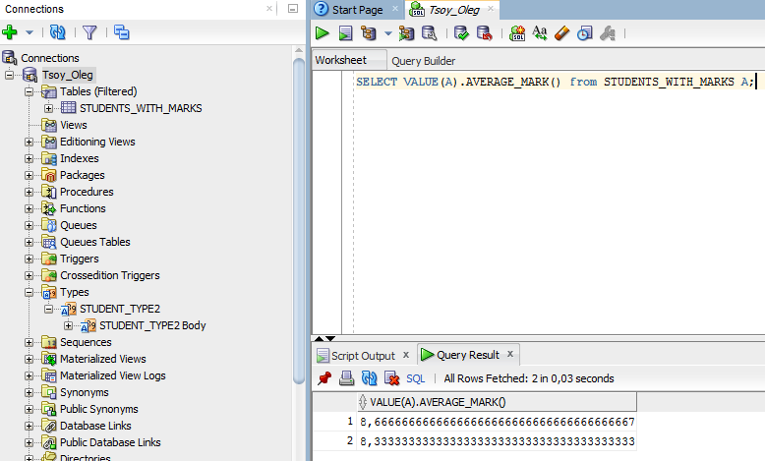

***Analysis of results, what in these data can be seen:*** *By this select statement function I presented the calculation function which was given in previous type body state. As can be seen from screenshot it gave us the AVERAGE_MARK of inputed marks of 2 students and automatically calculate them.*

***5. Query goal (ORDER type method):***

***Query SQL code***

CREATE OR REPLACE TYPE TYPE_ORDER

AS

OBJECT

(

LEVEL_NUMBER1 NUMBER,

LEVEL_NUMBER2 NUMBER,

ORDER MEMBER FUNCTION SORT(

P TYPE_ORDER)

RETURN INTEGER );

***Result of execution***

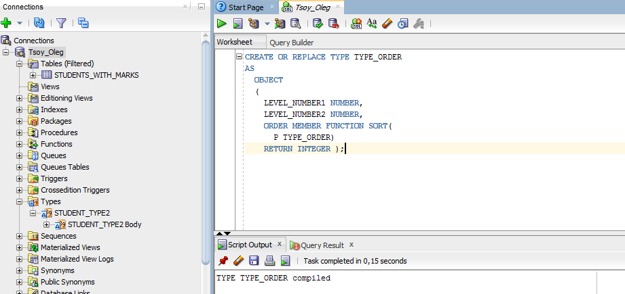

***Analysis of results, what in these data can be seen:*** *According to the query goal I have created TYPE_ORDER as an object to realize the ORDER function in my project.*

***6. Query goal (ORDER type method):***

***Query SQL code***

CREATE OR REPLACE TYPE BODY TYPE_ORDER

AS

ORDER MEMBER FUNCTION SORT(

P TYPE_ORDER)

RETURN INTEGER

IS

BEGIN

IF LEVEL_NUMBER1 < P.LEVEL_NUMBER1 THEN

RETURN -1;

ELSIF LEVEL_NUMBER1 > P.LEVEL_NUMBER1 THEN

RETURN 1;

ELSE

RETURN 0;

END IF;

END;

END;

***Result of execution***

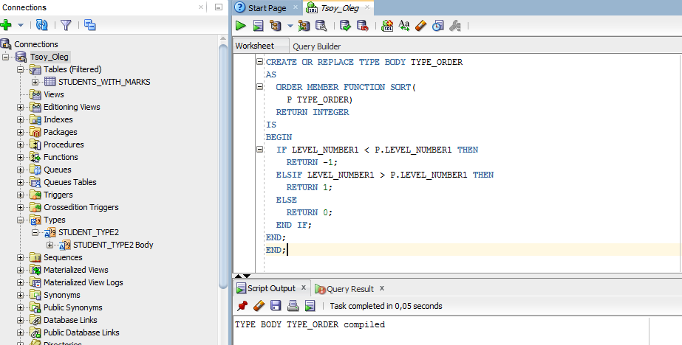

***Analysis of results, what in these data can be seen:*** *In this case I have created the TYPE_ORDER body as order member function sort where some requirements were included.*

***7. Query goal (ORDER type method):***

***Query SQL code***

CREATE TABLE TESTER1 OF TYPE_ORDER;

INSERT INTO TESTER1 VALUES (TYPE_ORDER(1,2));

INSERT INTO TESTER1 VALUES (TYPE_ORDER(3,4));

INSERT INTO TESTER1 VALUES (TYPE_ORDER(5,2));

INSERT INTO TESTER1 VALUES (TYPE_ORDER(1,6));

***Result of execution***

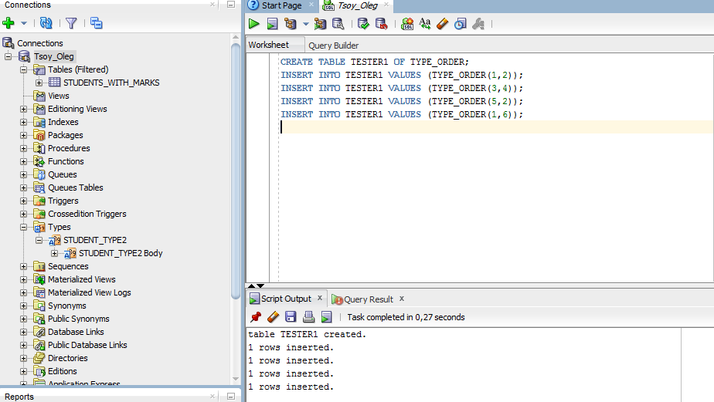

***Analysis of results, what in these data can be seen:*** *In this query I have created table TESTER1 of TYPE_ORDER, where I inserted 4 rows with needed values to show the main performance of this project in ORDER MEMBER function.*

***8. Query goal (ORDER type method):***

***Query SQL code***

SELECT A.SORT(TYPE_ORDER(3,5)) FROM TESTER1 A

***Result of execution***

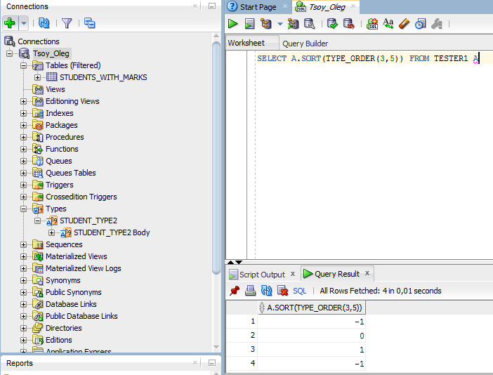

***Analysis of results, what in these data can be seen:*** *The SELECT statement in this case shows the sort of TYPE_ORDER values which were inserted below FROM table TESTER1.*

***9. Query goal (MEMBER type method):***

***Query SQL code***

CREATE TYPE STUDENT_TYPE3

AS

OBJECT

(

STUDENT_ID NUMBER,

NAME VARCHAR2(50),

MATHEMATICS_MARK NUMBER,

LDATABASE_MARK NUMBER,

LANGUAGE_MARK NUMBER,

MEMBER FUNCTION AVERAGE_MARK2

RETURN REAL);

***Result of execution***

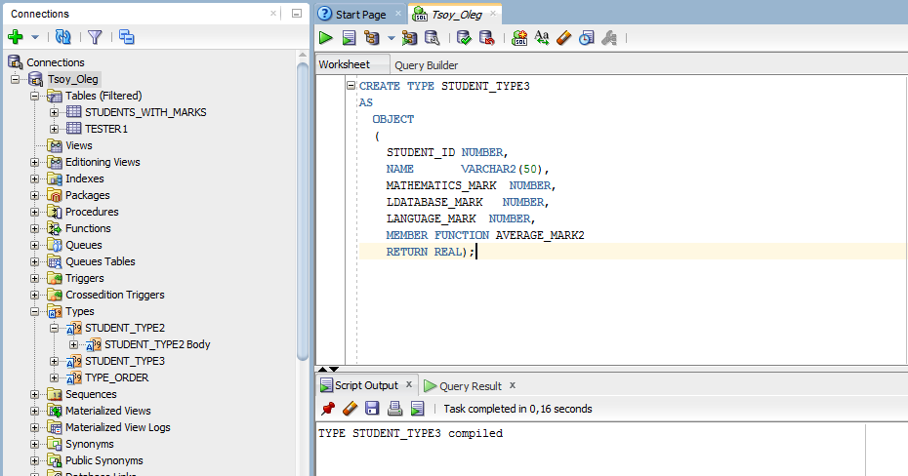

***Analysis of results, what in these data can be seen:*** *I have created the 3rd type student as an object with ID, Name, Marks for subjects and use member function AVERAGE_MARK2 which returned real numbers.*

***10. Query goal (MEMBER type method):***

***Query SQL code***

CREATE OR REPLACE TYPE BODY STUDENT_TYPE3

AS

MEMBER FUNCTION AVERAGE_MARK2

RETURN REAL

IS

BEGIN

RETURN (SELF.MATHEMATICS_MARK+SELF.LDATABASE_MARK+SELF.LANGUAGE_MARK)/3;

END AVERAGE_MARK2;

END;

***Result of execution***

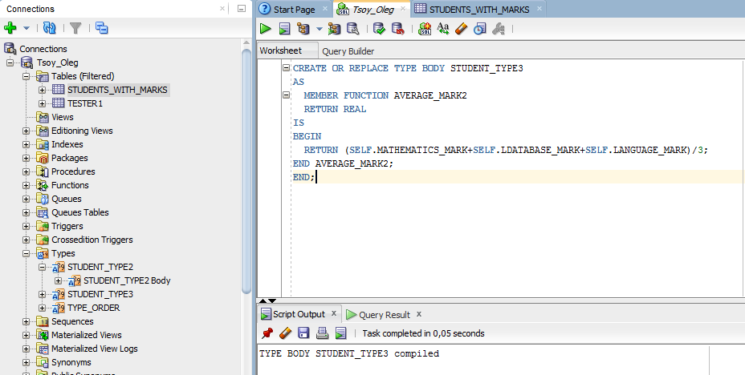

***Analysis of results, what in these data can be seen:*** *In this case the Body of student_type 3 was created with registered member function AVERAGE_MARK2, also the algorithm of calculating the AVERAGE_MARK2 was given in the code.*

***11. Query goal (MEMBER type method):***

***Query SQL code***

CREATE TABLE STUDENTS_WITH_MARKS2 OF STUDENT_TYPE3;

***Result of execution***

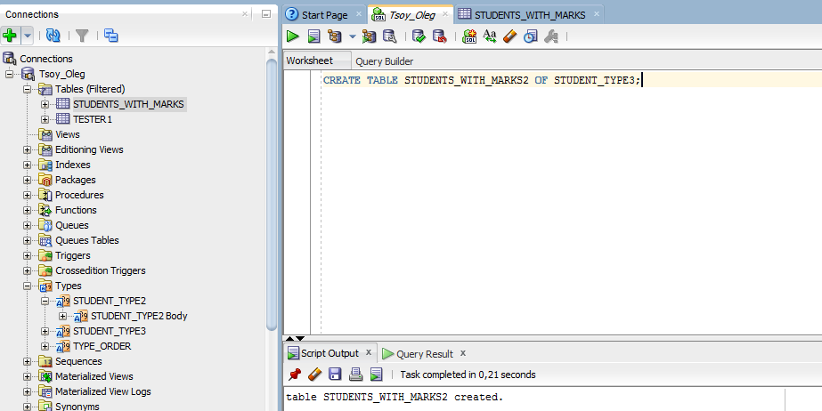

***Analysis of results, what in these data can be seen:*** *The table STUDENTS_WITH_MARKS2 was created for STUDENT_TYPE3 observations.*

***12. Query goal (MEMBER type method):***

***Query SQL code***

INSERT

INTO STUDENTS_WITH_MARKS2 VALUES

(

STUDENT_TYPE3(1,'OLEG TSOY',8,9,10)

);

INSERT

INTO STUDENTS_WITH_MARKS2 VALUES

(

STUDENT_TYPE3(2,'VLADISLAV TSOY',9,9,8)

);

INSERT

INTO STUDENTS_WITH_MARKS2 VALUES

(

STUDENT_TYPE3(3,'MAXIM TSOY',10,9,10)

);

***Result of execution***

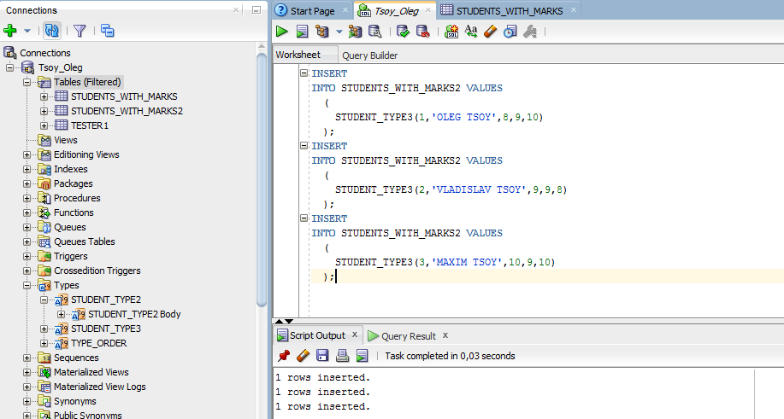

***Analysis of results, what in these data can be seen:*** *In this screenshot the inserted rows values were indicated for future manipulations.*

***13. Query goal (MEMBER type method):***

***Query SQL code***

*SELECT STUDENT_ID, NAME, VALUE(A).AVERAGE_MARK2() FROM STUDENTS_WITH_MARKS2 A;*

***Result of execution***

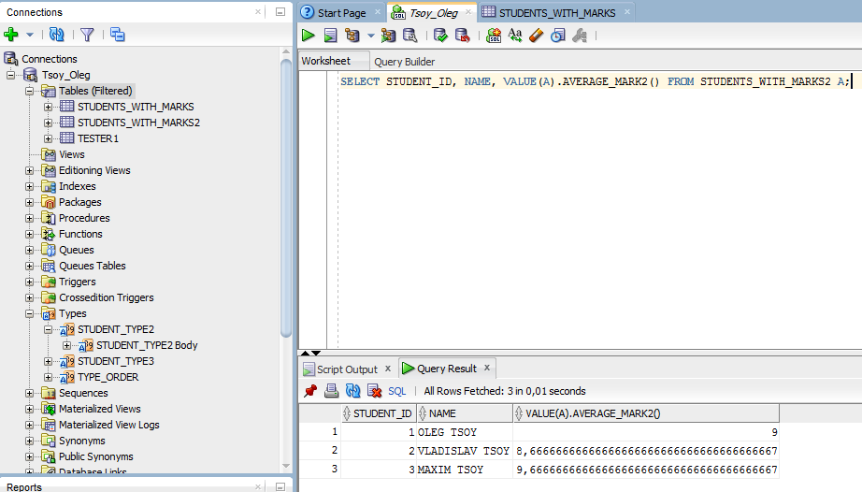

***Analysis of results, what in these data can be seen:*** *The demonstration of inserted data and the performance of the member function working calculations with inserted values.*

***14. Query goal (Using of LOADJAVA program):***

***Query SQL code***

CREATE OR REPLACE PROCEDURE CALL_SIMPLEJAVA

AS

LANGUAGE JAVA NAME 'SIMPLEJAVA.SHOWMESSAGE()';

***Result of execution***

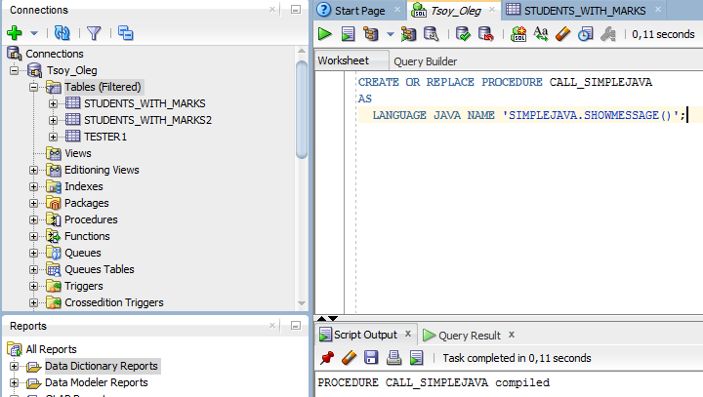

***Analysis of results, what in these data can be seen:*** *I have created call_simplejava as language java in my Database system.*

***15. Query goal (Using of LOADJAVA program):***

***Query SQL code***

SET SERVEROUTPUT ON;

CALL DBMS_JAVA.SET_OUTPUT(50);

***Result of execution***

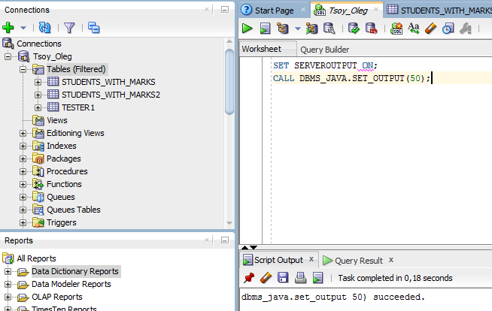

***Analysis of results, what in these data can be seen:*** *The server output by java programming language was succeeded.*

***16. Query goal (JAVA SELECT):***

***Query SQL code***

CREATE OR REPLACE JAVA SOURCE NAMED "MY_WORK" AS

IMPORT JAVA.SQL*;

IMPORT ORACLE.JDBC*;

IMPORT ORACLE.JDBC.POOL.ORACLEDATASOURCE;

CLASS MY_WORK {

PUBLIC STATIC VOID MAIN (STRING ARGS[])

THROWS SQLEXCEPTION {

STRING TEXT = NULL;

ORACLEDATASOURCE ODS = NEW ORACLEDATASOURCE();

ODS.SETURL(“JDBC:DEFAULT:CONNECTION:”);

CONNECTION CONN = ODS.GETCONNECTION();

STATEMENT COMMAND = NULL;

COMMAND = CONN.CREATESTATEMENT();

RESULTSET RESULTS = COMMAND.EXECUTEQUERY (“SELECT NAME FROM STUDENTS_WITH_MARKS2 WHERE STUDENT_ID = 1”);

WHILE (RESULTS NEXT()) { TEXT = RESULTS.GETSTRING(“NAME”);}

SYSTEM.OUT.PRINTLN ("STUDENT WITH STUDENT_ID 1:” + TEXT);

RESULTS.CLOSE();

COMMAND.CLOSE();

CONN.CLOSE(); } }

***Result of execution***

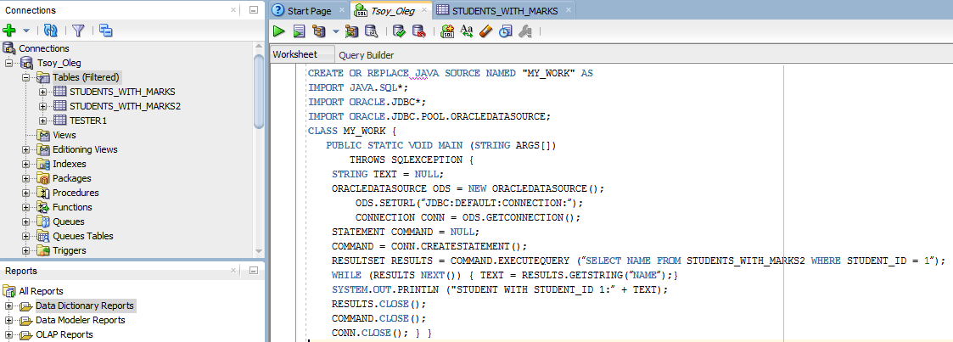



***Analysis of results, what in these data can be seen:*** *Execution of JAVA language meta-data inspection.*

***17. Query goal (CREATE JAVA procedure):***

***Query SQL code***

CREATE OR REPLACE PROCEDURE MY_WORK

AS

LANGUAGE JAVA NAME 'MY_WORK.MAIN(java.lang.String[])';

***Result of execution***

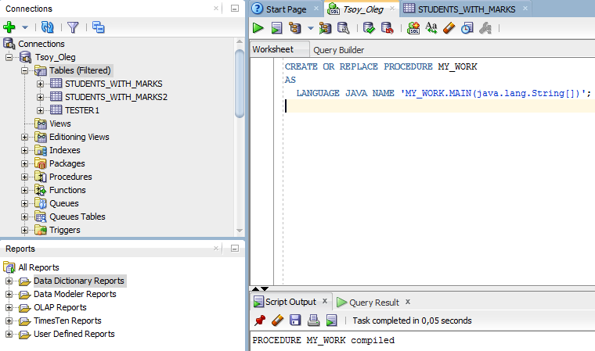

***Analysis of results, what in these data can be seen:*** *Procedure MY_WORK was compiled successfully. That shows that creation of the procedure MY_WORK which is MAIN format has language JAVA as a priority created language.*

***18. Query goal (serveroutput of JAVA procedure):***

***Query SQL code***

SET SERVEROUTPUT ON;

CALL DBMS_JAVA.SET_OUTPUT(2000);

CALL MY_WORK();

***Result of execution***

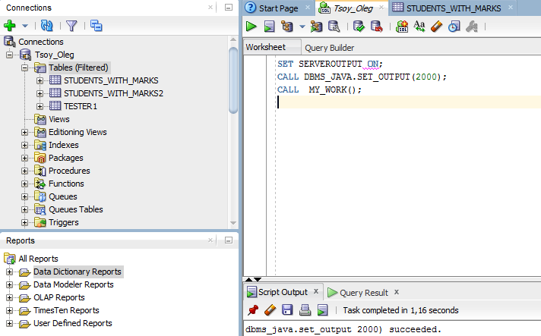

***Analysis of results, what in these data can be seen:*** *In this case we can observe that this query call the execution of MY_WORK procedure.*

# Conclusion

*As can be concluded from this project description I can say that it was the most difficult database project for me because of the existence of JAVA programming language for comparing all data. While, I found some advantages in using of the programming language or IDE which can provide the highest performance in my procedures and simplify the initial code structure. In my case I used Eclipse IDE for compiling JAVA with Oracle Database Management System as can be seen from the most cases in my preview. The problematic part of this host was to find the path how to realize the code description due to the SQL developer and SQL* Plus developer have the different structure. However, I was late after reading the materials about them that is why it was my main problem in this case.*